Caterpillar Foundation Matching Gifts Program Process – St Jude Drivers Association

- Visit www.caterpillar.com/matching-gifts and click the “Caterpillar Participants – Request a Match”.

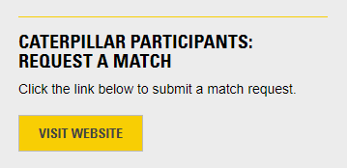

- Register as a first-time user or login as an existing user. Click “I Accept” to the matching gifts terms and conditions.

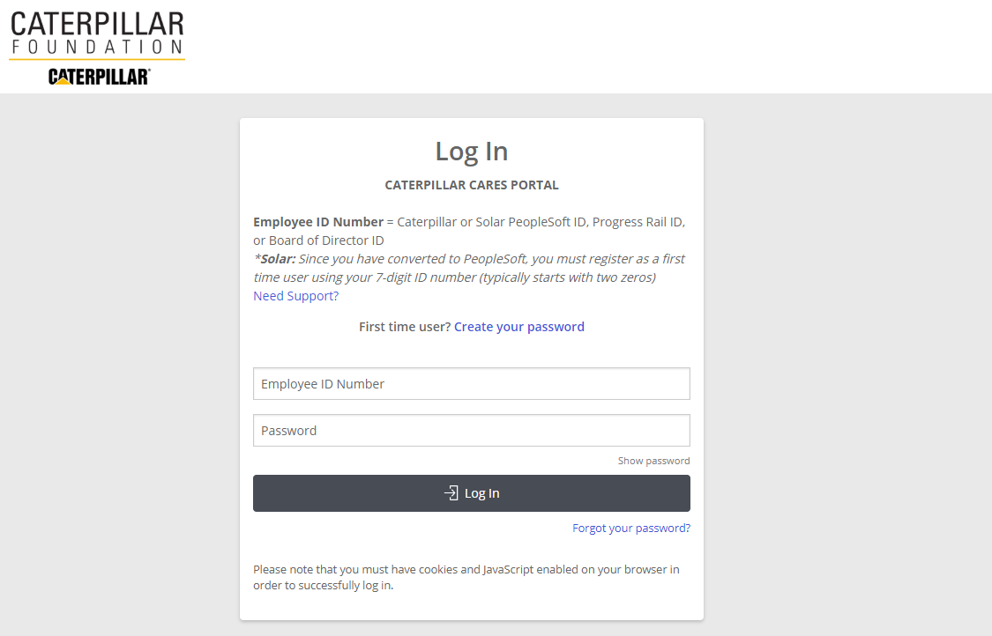

- From home page, click “Submit a Matching Gift Request”.
- Search for “St Jude Drivers”.

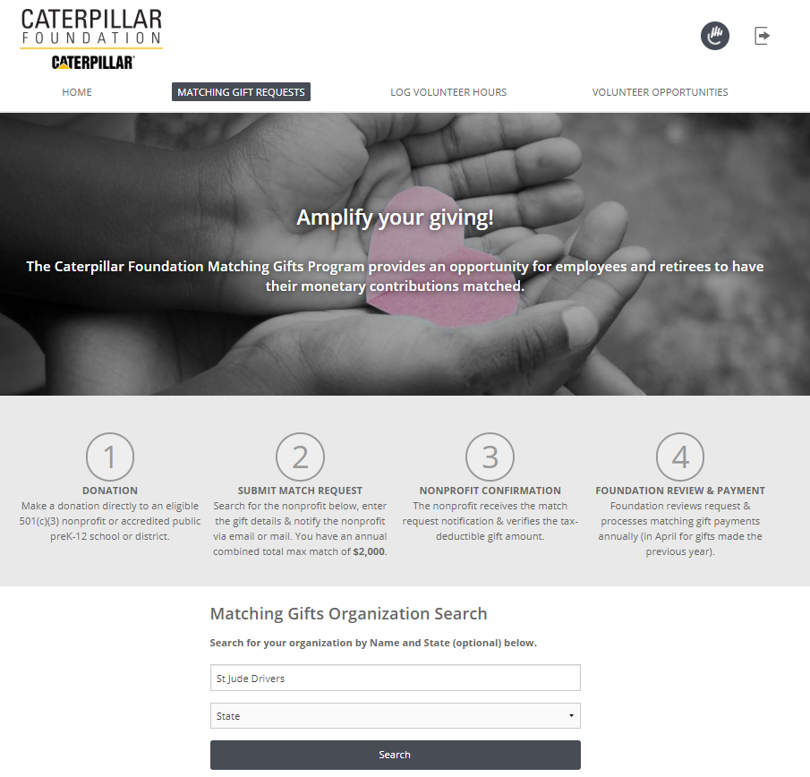

- Select “St Jude Drivers Association”.

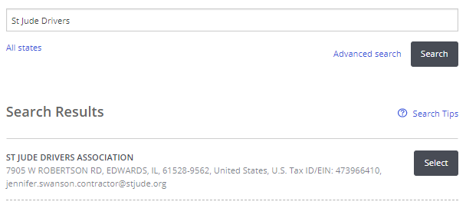
- Enter gift details.

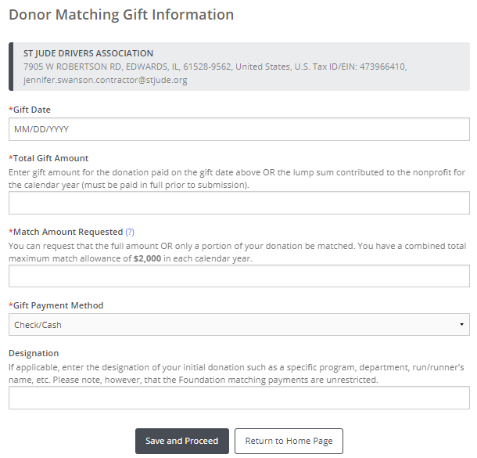

- Review match request and click submit.

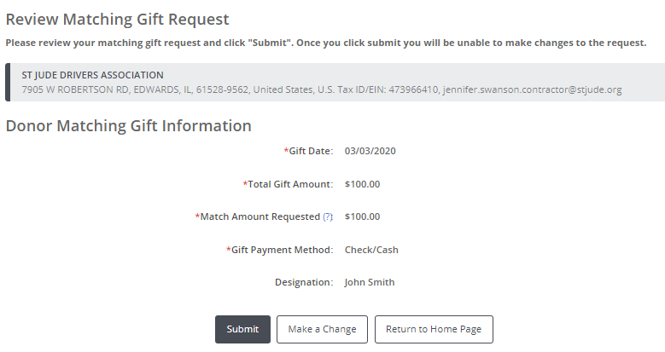

- Mail or email match request to the nonprofit.

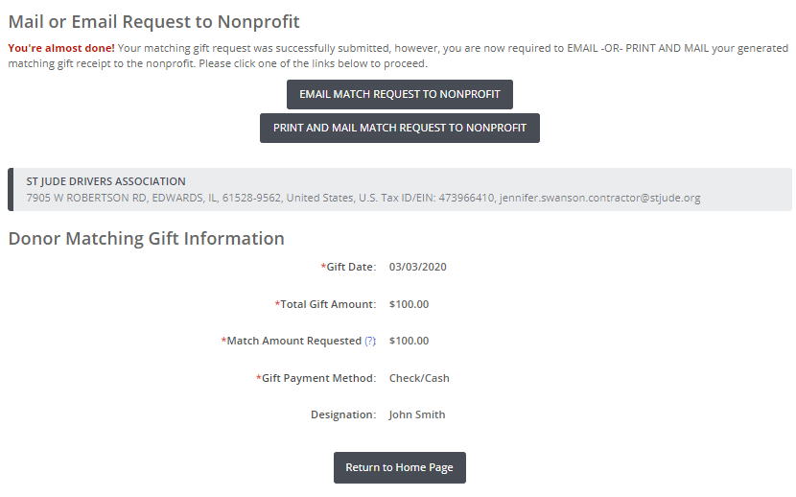

- To email, enter jennifer.swanson.contractor@stjude.org into Recipient field. Scroll down and click “Preview”. You do not need to upload any attachments or include additional messages.

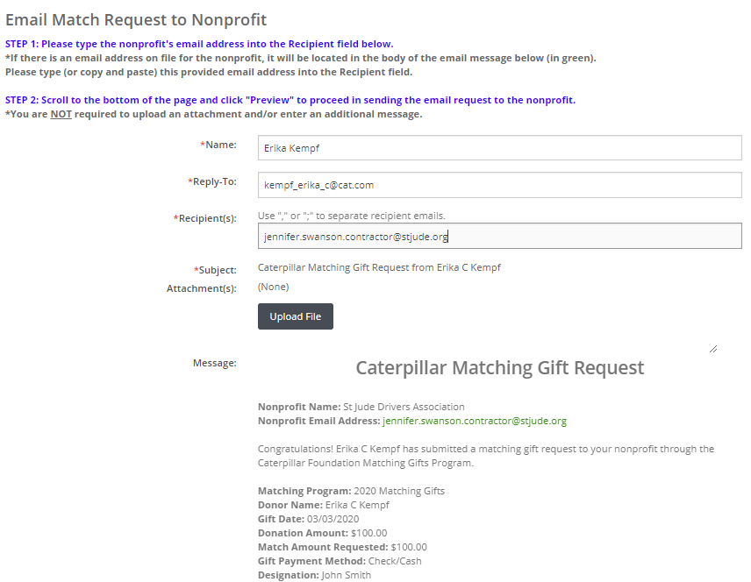

- Scroll down to bottom of the page and click “Send”.

